Publish report for Coded UI and unit test to Team Foundation Server

In this exercise we will find out how to send the result of automated test to Team Foundation Server. In order to do it we will first create automated tests, associate them to Test Cases, run using mstest utility and publish the result with tcm utility

1. Start Visual Studio 2017 Enterprise edition and create a new Project of type Coded UI Test. Click on Cancel as we will write the code from scratch.
2. Add following code to the test method  
   BrowserWindow browser = BrowserWindow.Launch("https://www.google.com/");  
   UITestControl uiSearch = new UITestControl(browser);  
   uiSearch.TechnologyName = "Web";  
   uiSearch.SearchProperties.Add("ControlType", "Edit");  
   uiSearch.SearchProperties.Add("Name", "q");  
   iSearch.SetFocus();  
   uiSearch.SetProperty("Text", "Coded UI");  
   System.Threading.Thread.Sleep(5000);

1. The code is very simple which starts browser, goes to google site, enters search to text and waits for 5 seconds. Let us execute the test from Visual Studio with Test Explorer and ensure that it passes.
2. Create a new workitem of type Test Case within the same project. Provide a title for it and save it. Right click on the test in Test Explorer and select Associate to Test Case  
     
   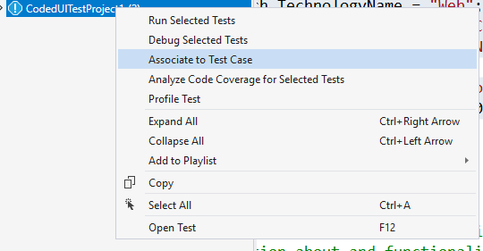
3. Provide the test case Id and click on Add Association button followed by Save button as follows  
   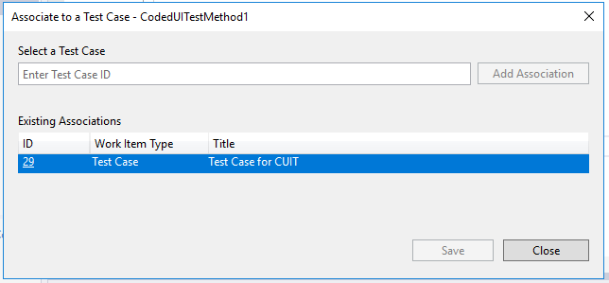
4. Let us also add a unit test in the same project. Provide simple code for the unit test case and execute it to ensure that it fails.
5. Repeat the step of associating code to another test case for the unit test.
6. Start Developer Command prompt for Visual Studio 2017 and provide following command  
   mstest /testcontainer:"<path for test project>\<test project dll>" /resultsfile:latest.trx  
   This will execute all the tests from the dll and keep the result in latest.trx file as mentioned in command. The location of .trx file is <driver location>\\Program Files (x86)\Microsoft Visual Studio\2017\Enterprise  
   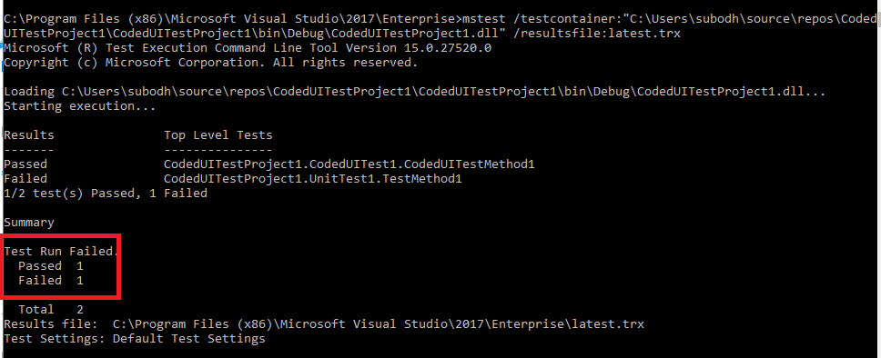  
   Observe that the run has failed for one and passed for one.
7. Now in order to publish results using .trx file to Team Foundation Server we need a suite created in MTM and with default configuration.
8. Start Microsoft Test Manager 2017 and connect to the TFS, select the collection, project name and provide a new Test Plan name. Click on Select plan.  
   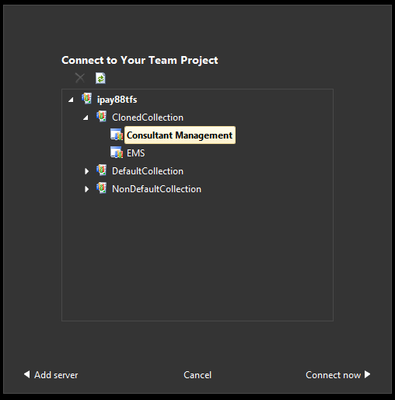  
   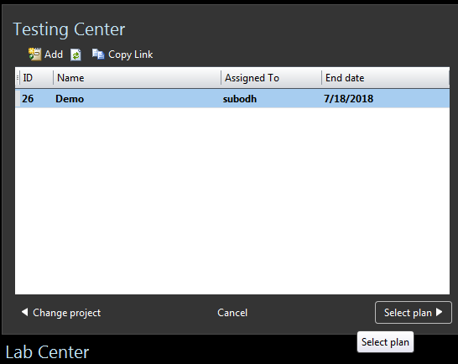
9. Click on New – Suite from Plan Tab and provide proper name for the suite  
   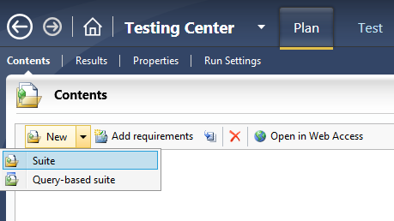
10. Add both the test case to this plan (the ones we have already associated with the code from Visual Studio)
11. Go back to the command prompt and enter following command  
    tcm run /publish /suiteid:<id> /configid:<id> /resultowner:"<your owner name>" /resultsfile:"C:\Program Files (x86)\Microsoft Visual Studio\2017\Enterprise\latest.trx" /collection:http://localhost:8080/tfs/<collection name> /teamproject:"<project name>"
12. You will get a message saying that the results are published. Select Test tab and select individual test case. Right click on it and click on View Results.  
    For 1 test case you will get the result as passed and for the other as failed  
    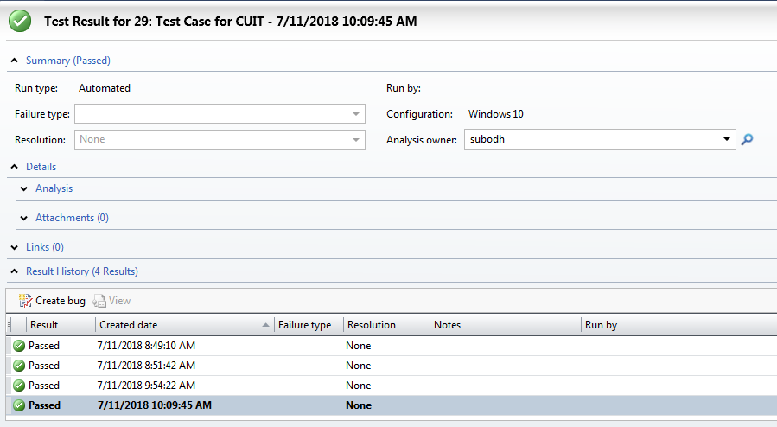  
      
    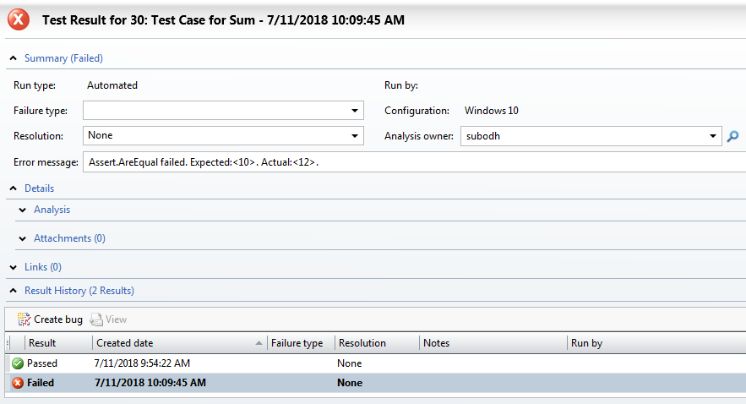
13. If you want to publish result multiple times you need separate .trx file for it.